No. GM (S&M-CM )/T-316/10-11/ /Vol I / 4 dt 05/03/2011
To
All Heads of SSAs,
Tamil Nadu Circle.

Sub:-Tripartite agreement form between BSNL, Franchisee and Sub franchisees -Reg
Ref: BSNL HQ letter No. 27-9/2009-SM-CM/Pt2 dated 01.01.2010

The Tripartite agreement form between BSNL, Franchisee and Sub franchisee prepared as per the S&D Policy 2009 for appointing sub franchisees by the Franchisees for marketing the Consumer Mobility products is enclosed herewith for further necessary action at your end.
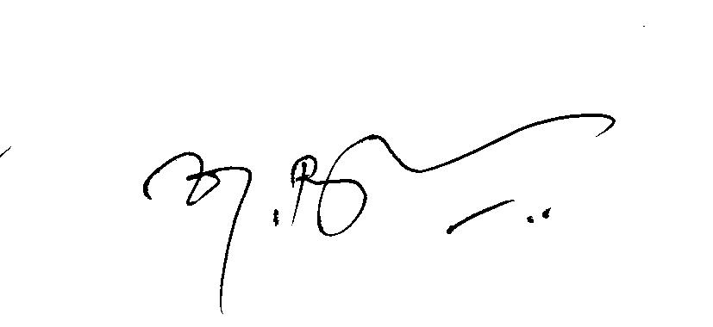

(K. Rathakrishnan)
Deputy General Manager (S&M-CM)
Chennai, Tamil Nadu Circle.
Mobile: 94432 00336
Copy To:1.GM(TR),ch-TN circle
2. AGM (sales)/AO(sales),TN circle.
3.All franchisees in Tamil Nadu circle

Specimen Tripartite Agreement form between BSNL , Franchisee and
Sub Franchisee
THIS TRIPARTITE FRANCHISEESHIP AGREEMENT is made at this the ___________ day of ___________ 2011, BETWEEN __________ ____________Telecom Circle / District, of Bharat Sanchar Nigam Limited (BSNL), a Company incorporated under the Companies Act, 1956 having its Registered Office & Corporate Office at Bharat Sanchar Bhawan, Harish Chandra Mathur Lane, Janpath, New Delhi-110001 Circle office at ____ __________and SSA at_______ _____(hereinafter referred to as “BSNL” which expression shall be deemed to include its successors and assigns wherever the context so admits or requires) through its duly authorized representative Mr. _____________________________________ of ____________________________SSA, herein after called THE FIRST PARTY.

AND
M/s _____________________________________(hereinafter referred to as the “Franchisee-CM” (or Franchisee in short, both terms have been used in this document interchangeably) which expression shall include his servants, heirs, executors and administrators wherever the context so admits or requires) through its authorized representative, Mr._________________________herein after called THE SECOND PARTY

AND
M/s _________________________________ (hereinafter referred to as the “ Sub Franchisee-CM” (or Sub Franchisee in short, both terms have been used in this document interchangeably) which expression shall include his servants, heirs, executors and administrators wherever the context so admits or requires) through its authorized representative, Mr. _______________________________________ herein after called THE THIRD PARTY.
Whereas
1.1BSNL has appointed M/s--------------- --------------as Franchisee for the ------------------ territory in -------------------- SSA for a period of --- years from ------------------ for Sales, Marketing and Distribution of Consumer Mobility Products through the retailer outlets and other sales point in the approved territory as per the BSNL Sales and Distribution policy 2009 and signed a agreement to that effect with BSNL

1.2: As per the S & D Policy in the interest of increasing the customer base, the Franchisee can appoint Sub Franchisees for booking new connection and selling of prepaid cards and other CM products. FoS shall be appointed for servicing the retailers (may be in consultation with Franchisee/BSNL).
1.3 As per the S & D Policy 2009 , the second party (M/s. ---------------------------------- BSNL Franchisee of ---------------------------------Territory in ------------------------------- SSA) appoints Mr/Ms/M/s.--------------------------------- s/o/d/o ------------------------------------------------- residing at ------------------------------------------------- as Sub Franchisee for serving --------------------------------------------------------------------------------------------- locality under him/her/them for a period from ------------------------------ to -----------------------------
1.4. The Sub Franchisee is licensed to market and distribute the BSNL consumer products in the area allotted by the franchisee and appoint FoS (feet on street) for delivering the product to retails shops allotted to him
1.5. The commission and other benefits entitled to the sub Franchisee will be passed on by the Second Party i.e. BSNL Franchisee as per the S & D policy 2009 and guidelines issued from time to time.
1.6 The Sub Franchisee shall treat as confidential and secret all verbal and written communication, lists and circulars which in the opinion of the BSNL are regarded as confidential information and/or trade secrets. The Franchisee shall adopt and implement security procedures acceptable to the BSNL for determining the persons to whom such information is authorized to be disclosed based upon such person’s need to know the same for the purpose of fulfilling his responsibilities in relation to the Agreement. Confidential and trade secret information shall remain the property of the BSNL and shall be returned to the BSNL upon termination of this Agreement in the manner prescribed by the BSNL. The Sub Franchisee hereby undertakes and agrees not to retain and make any copies of the entrusted confidential information.
1.7 Tax Liability: Sub Franchisee has to bear all applicable taxes as per Central / States/ Local Laws.
1.8 This agreement is more of a nature of license. The BSNL/Franchisee has the right to terminate this agreement forthwith in case it comes to conclusion that the sub Franchisee has violated any of the clauses of the agreement which has resulted in or could result in loss to the BSNL/Franchisee or may cause damage to the service being provided by the BSNL. The decision of the BSNL/Franchisee will be final in this regard.
1.9 In case of loss of stock of BSNL Products issued by the Franchisee, the sub Franchisee shall immediately report the same to the Franchisee with the copy of F.I.R.
2.0 The Sub Franchisee shall carry out its obligation under this agreement at its own cost and expenses and no reimbursement whatsoever shall be made by the Franchisee / BSNL on any account whatsoever.
2.1 The Sub Franchisee shall be fully responsible for the employment or payment of wages to its employees and shall fully comply with all laws, rules, regulations, notifications, directions orders etc. of the Govt. whether Central, State, Local or Municipal relating to such employment, payment of wages etc. and all others matter connected therewith and hereby indemnifies and agrees to continue indemnifying the Franchisee /BSNL in this regard.
2.2 Sub Franchisee will be serviced by Franchisee and may not be exclusive to BSNL.
2.3 Franchisee should serve Sub Franchisee. Sub Franchisee in turn will serve the retailers under him at their premises. In case, where a retailer is served through a Sub Franchisee, share of franchisee as applicable will be shared between Franchisee and Sub Franchisee. No change in the share of retailer will be allowed.
2.4.The Franchisee (second party) accepts to pay commission/discounts to Sub franchisee(third party) for the products at the rate -----% within the Franchisee entitlement at present and it may be increased on the basis further business transactions done by the Sub Franchisee
2.5 Franchisee is responsible for keeping the record of material received, sold and available with Sub Franchisee and all his retailers on a daily basis through BSNL–specified IT system.
2.6 BSNL is not responsible for any financial transactions between the Franchisee and Sub Franchisee. Any disputes arising between them should be solely settled by Franchisee and Sub Franchisee.
For and on behalf of the Franchisee For and on behalf of the BSNL
Signature ____________________ Signature ________________________
Name________________________ Name __________________________
(In capital letters) (In capital letters)
Executive Director / Prop._________ Designation_______________________
For and on behalf of the Sub Franchisee
Signature ____________________
Name & Address_________________
_______________________________
_______________________________
Signature of witness (BSNL) with full address Signature of witness (Franchisee) with
full address
Signature ______________________ Signature _____________________
Name & Address_________________ Name & Address_________________
_______________________________ _______________________________
Signature of witness (Sub Franchisee) with full address
Name & Address ____________________________
___________________________________________
Dated at ____________________on _____________

